**DS501 Case Study 3 Report**

MovieLens is a website that recommends movies for users based on the user’s film preferences. Using the MovieLens 1M dataset, we explored the data, proved or refuted our conjectures, and built a narrative to help answer the question: What demographics should we target to boost users on a streaming platform, based on MovieLens users?

The MovieLens 1M dataset contained 1,000,209 ratings of approximately 3,900 movies

made by 6,040 MovieLens users. Information was spread across 3 tables: ratings, user information, and movie information. Each of these tables had variables we were interested in analyzing, as well as overlapping variables. Therefore, the group decided to merge the three data tables into an easier-to-use data frame for analysis. The data was downloaded as:

1. movies: 'movie_id', 'title', 'genres'
2. ratings: 'user_id', 'movie_id', 'rating', 'timestamp'
3. users: 'user_id', 'gender', 'age', 'occupation', 'zip'

Therefore, the preliminary merged data frame looked like the following:

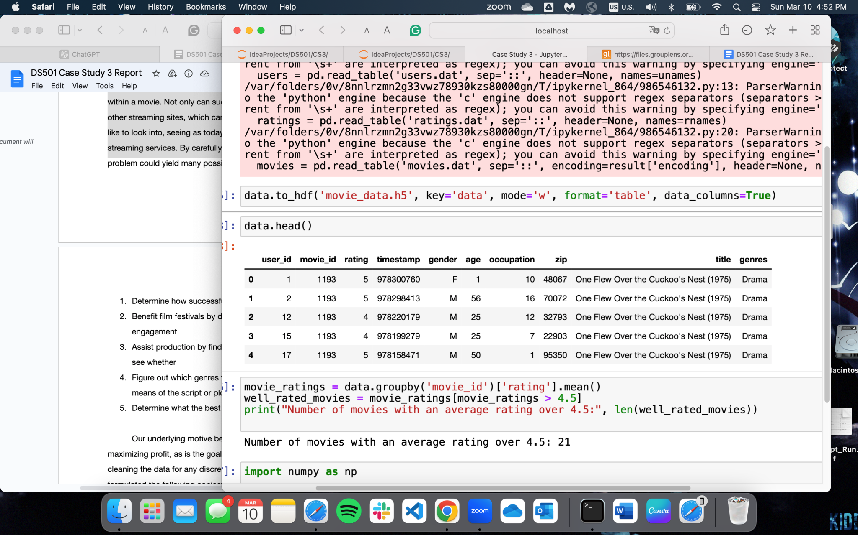

The group utilized both Pandas DataFrames and pivot tables to manipulate and analyze the dataset efficiently.

# **About the Data**

The final data frame has 1000209 rows and 10 columns. All data was present. The columns of the dataframe are: MovieID, Title, Genres, UserID, Rating, Timestamp, Gender, Age, Occupation, Zip-code.

# **Solutions**

1. Problem 1:

* Movies have an average rating of over 4.5 is 21 movies

|  | Female | Male |
| --- | --- | --- |
| # movies have average rating over 4.5 across gender | 51 | 23 |
| # movies with a median rating over 4.5 among those over 30 across gender | 149 | 86 |
| # of ratings | 246440 | 753769 |
| Average rating across all movies | 3.620366 | 3.568879 |

Additionally, we found the top 10 most popular movies to be the following:

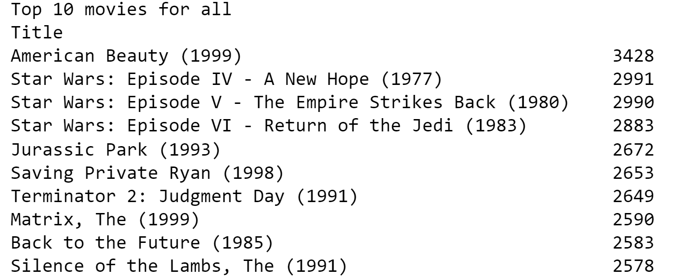

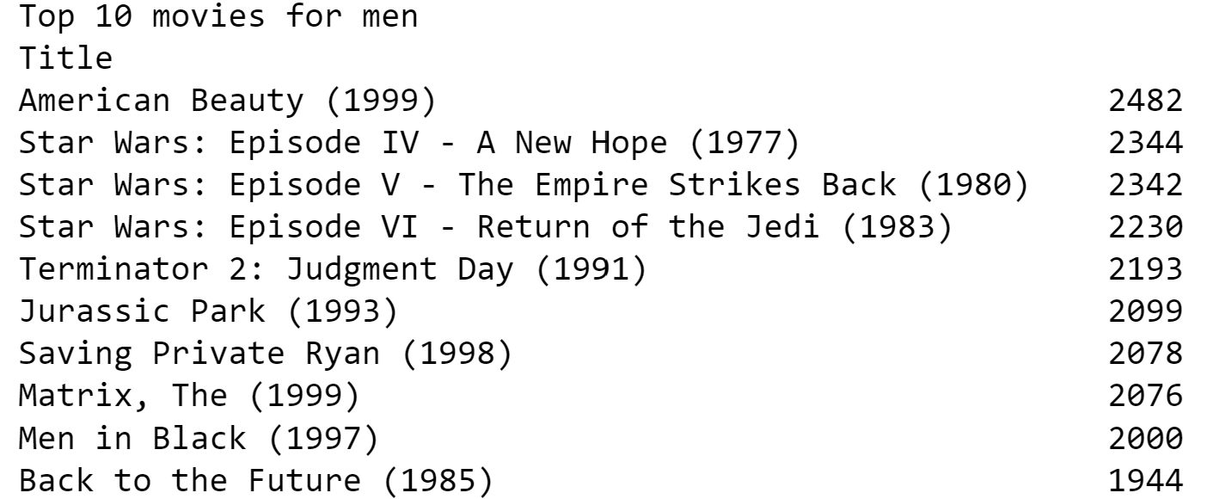

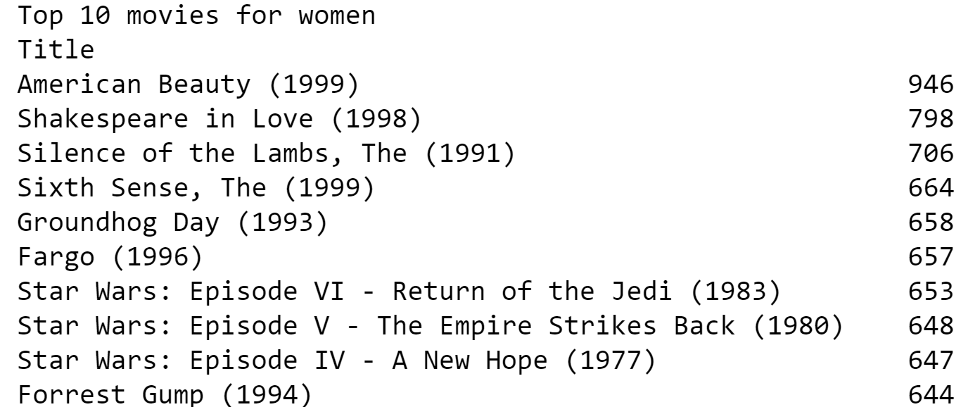

We considered the number of ratings to be a metric for popularity. We decided against using the average rating as we felt like a highly-rated movie could be because it has a low number of ratings. The number of ratings was a better indicator of how many people watched the movie.

Conjecture 1a)

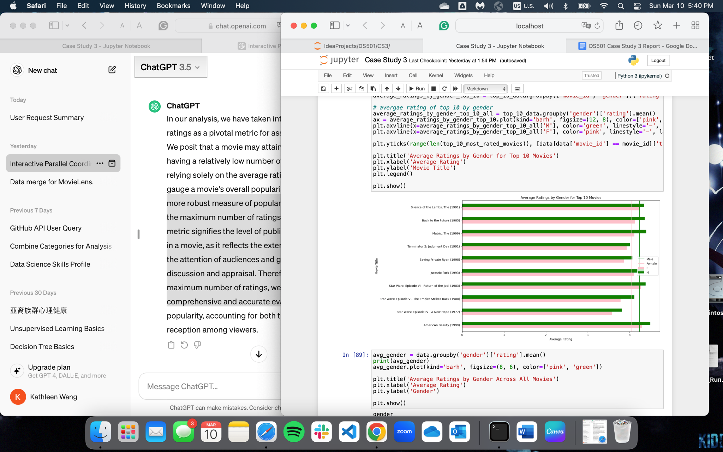

In the top 10 most popular movies for all, we also analyze the ratings of Male and Female for those movies. The result is that we make a conjecture that male viewers are easier to please than female viewers in the top 10 movies due to their higher average ratings.

Conjecture 1b) and 1c)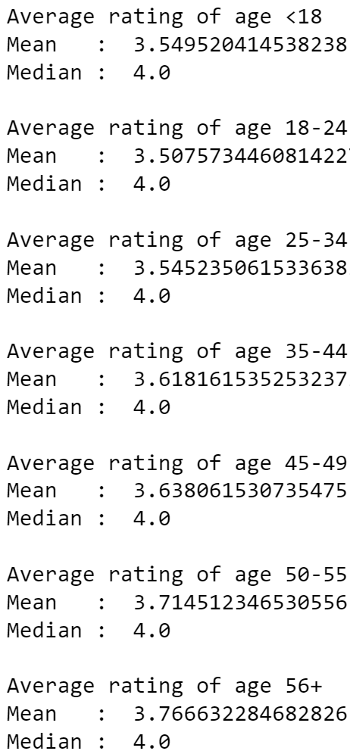

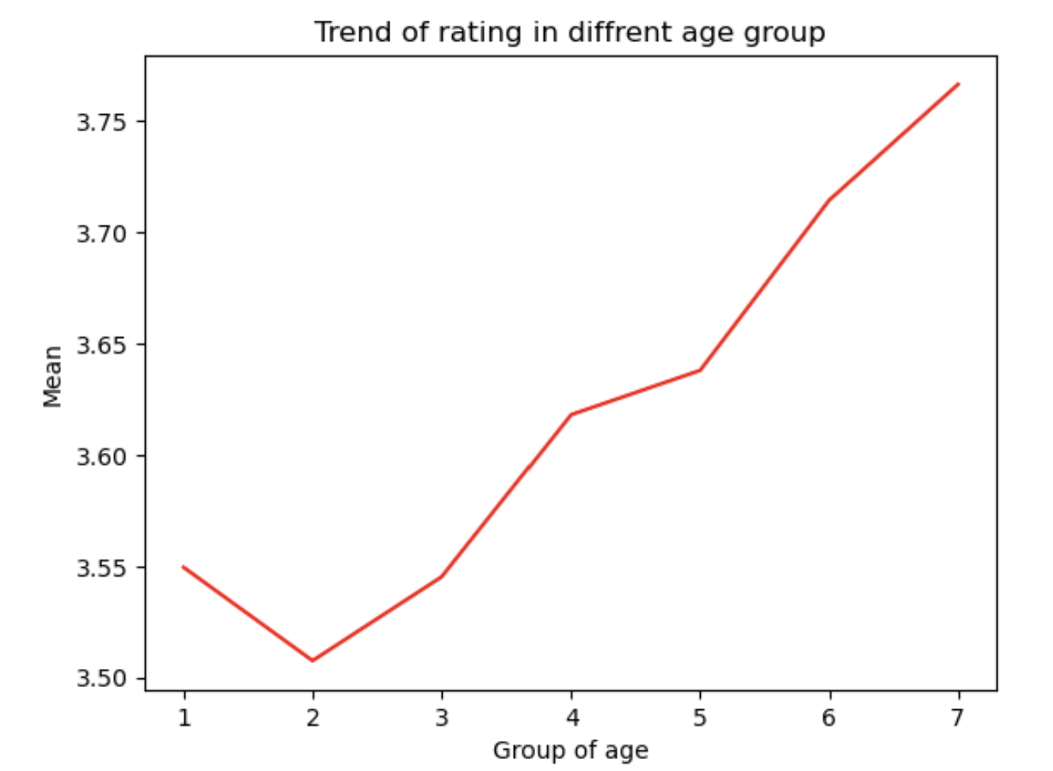

From this graph and the mean and median ratings in all age groups, we can make two conjectures. Firstly, the trend is since the age of 18 above, the older group tend to have a higher rating, where for this dataset, people at the age of 56+ is the easiest age group to please. Secondly, people tend to rate 4 stars.

Additionally, for this problem we also make two graphs to show the ratings distribution.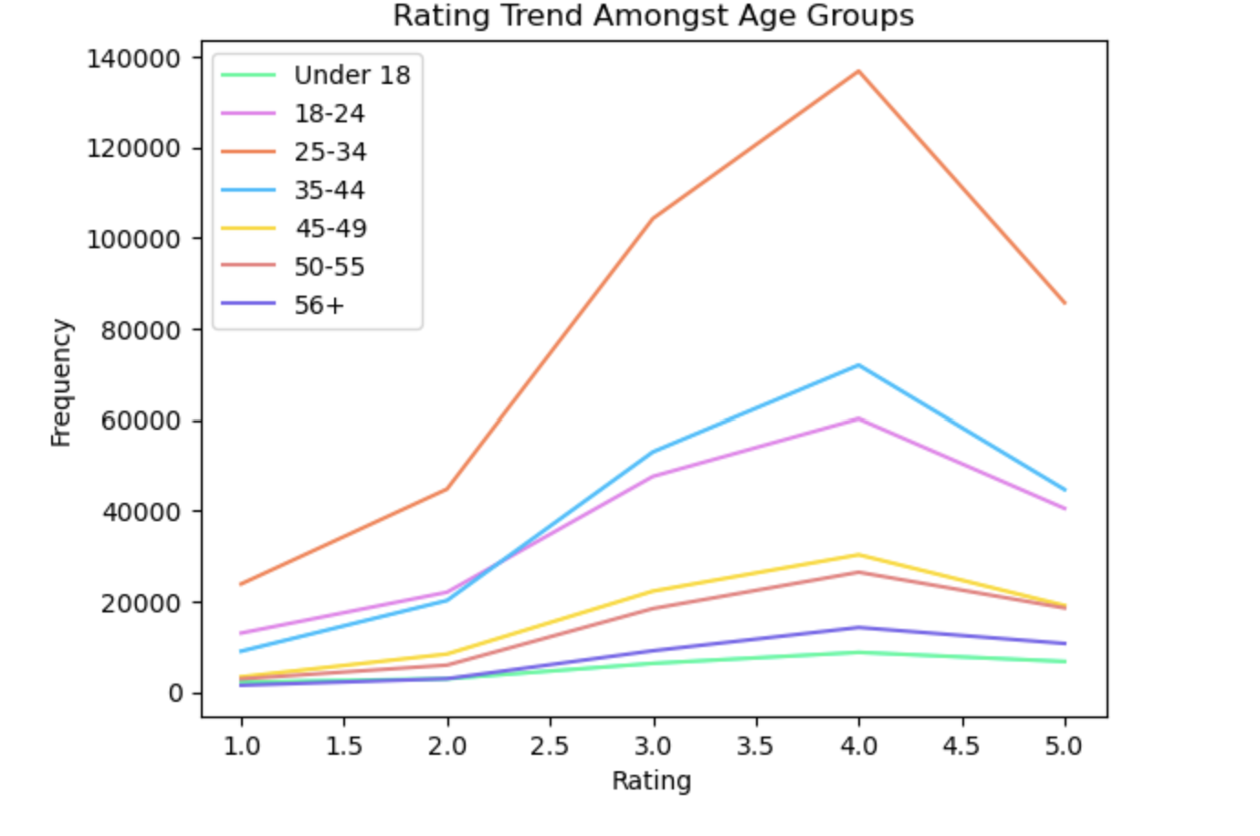

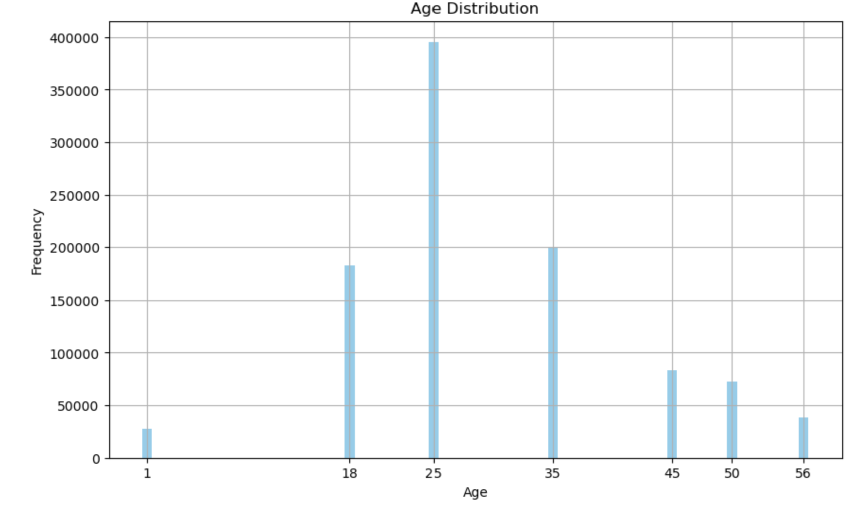

1. Problem 2:

* Histogram of the ratings of all movies

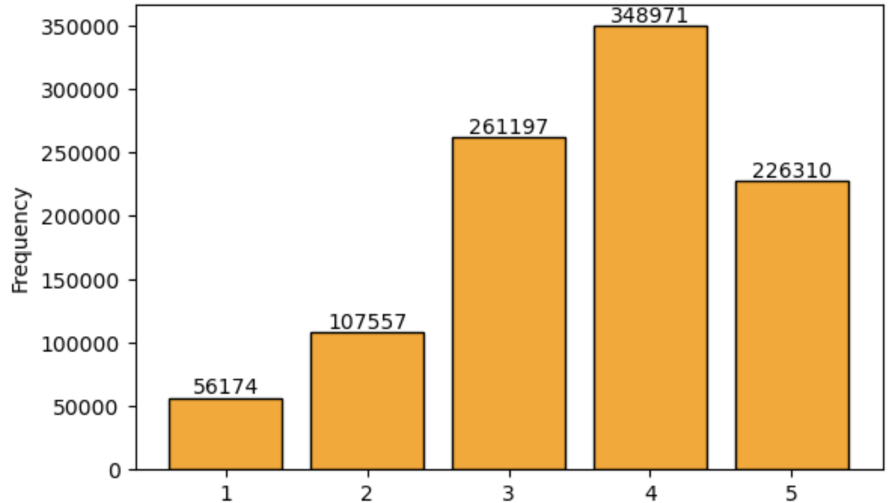

* Histogram of the *number* of ratings each movie received.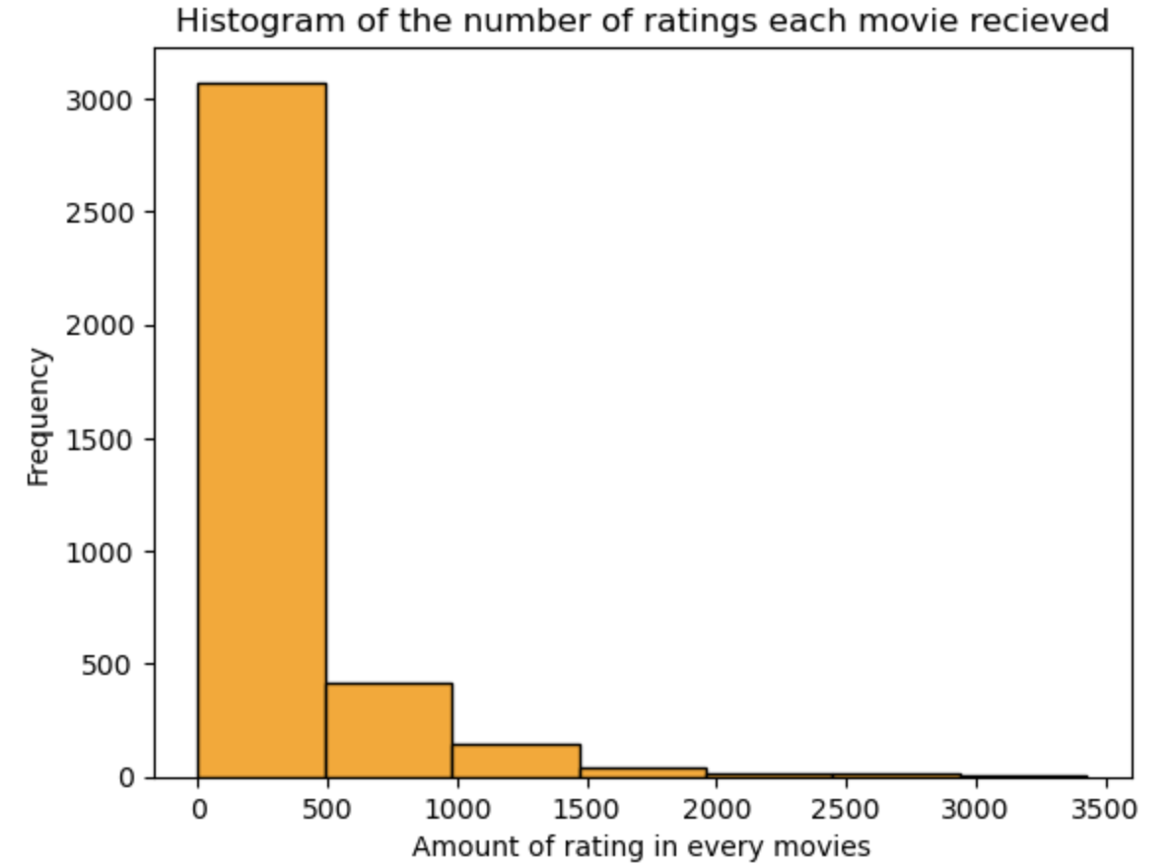
* Histogram of the *average rating* for each movie.

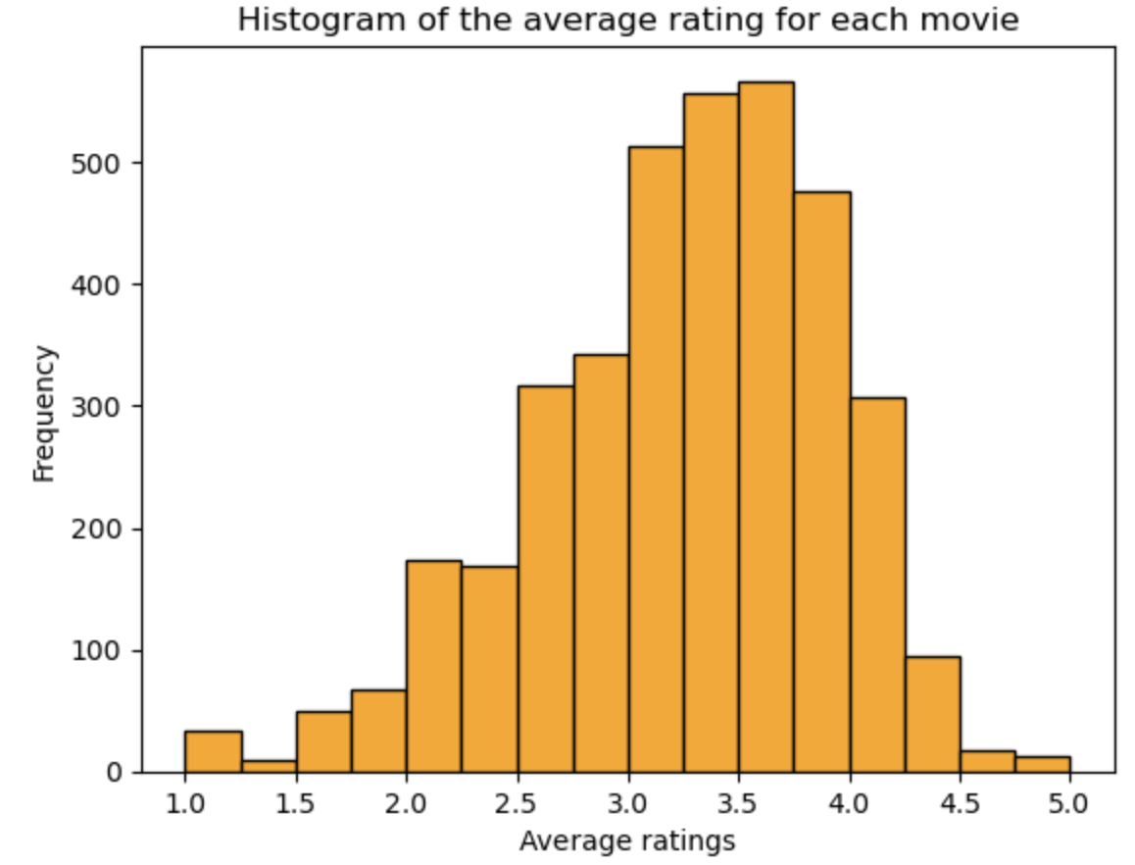

* Histogram of the *average rating* for movies which are rated more than 100 times.

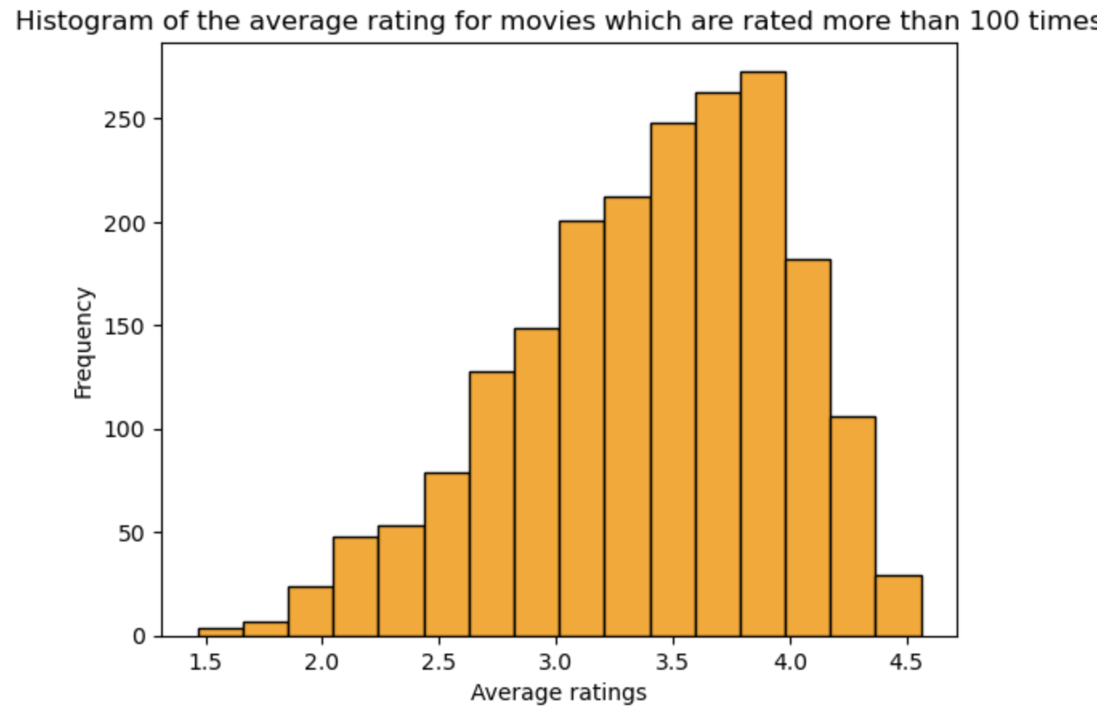

Both histograms have skewed left distribution. However, the tail of the histogram for all movies is shorter than that of the histogram for movies with more than 100 ratings. This means that the average ratings of all movies is smaller than that of movies with more than 100 ratings. I would highly trust movies with more than 100 ratings. Based on the previous conclusion, movies with less than 100 ratings must tend to have smaller average ratings than all movies.

Conjecture 2a and 2b)

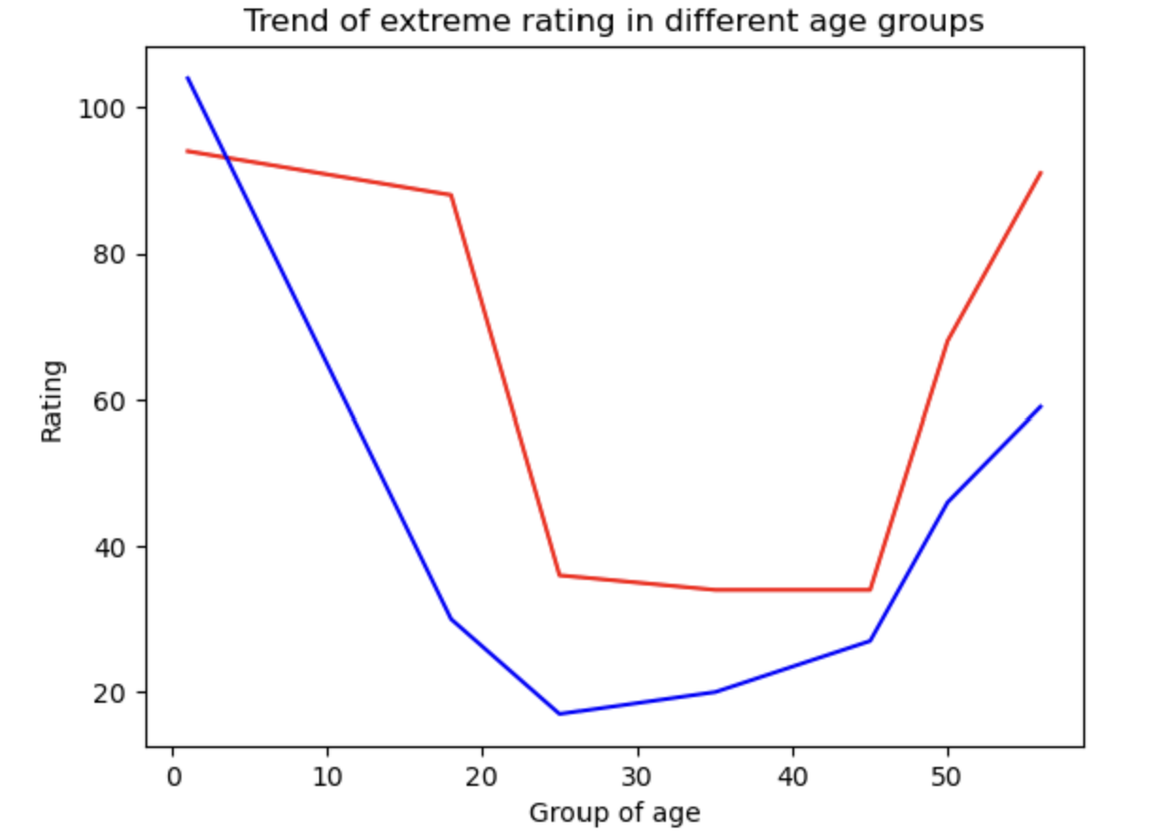

* This plot is about the polarity in rating across age groups, where the red line is one star rating among a certain age group and the blue line is the five star rating among that age group.
* From the plot, we can conclude that people under 18 tend to have more extreme ratings.
* Secondly, we also can conclude that most age groups tend to rate movies with one one star over five.

1. Problem 3:

Scatter plot of men versus women and their mean rating for every movie.

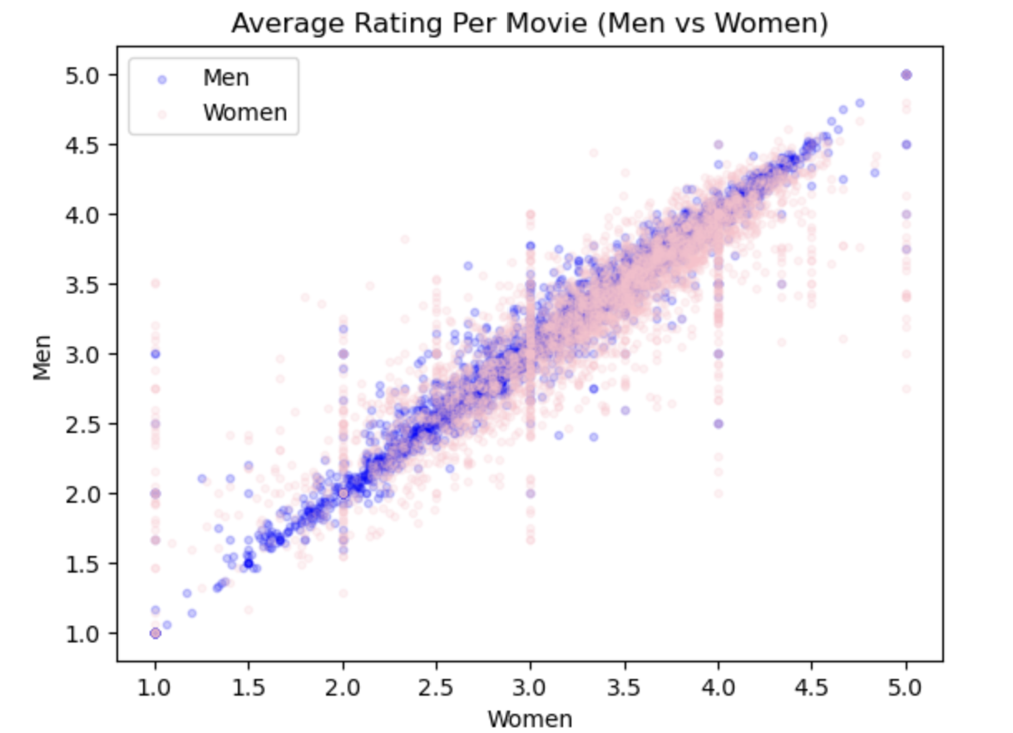

Scatter plot of men versus women and their mean rating for movies rated more than 200 times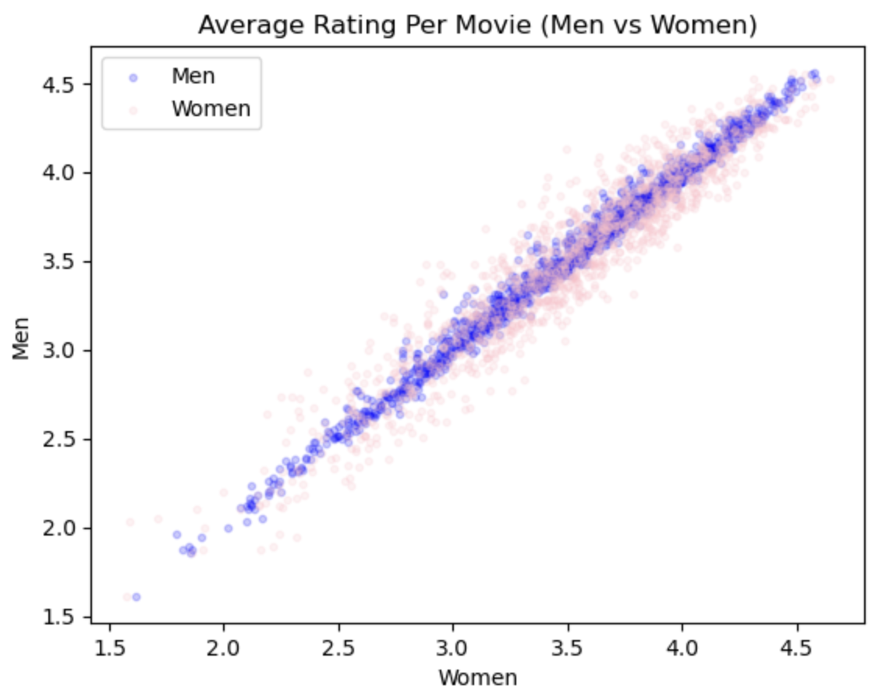

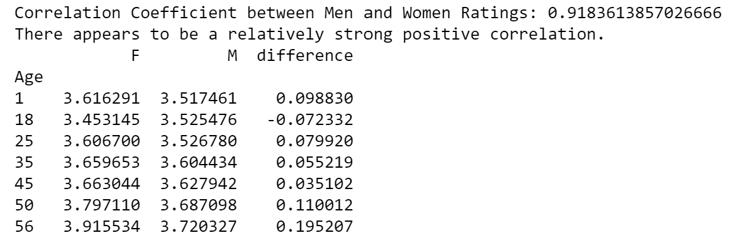

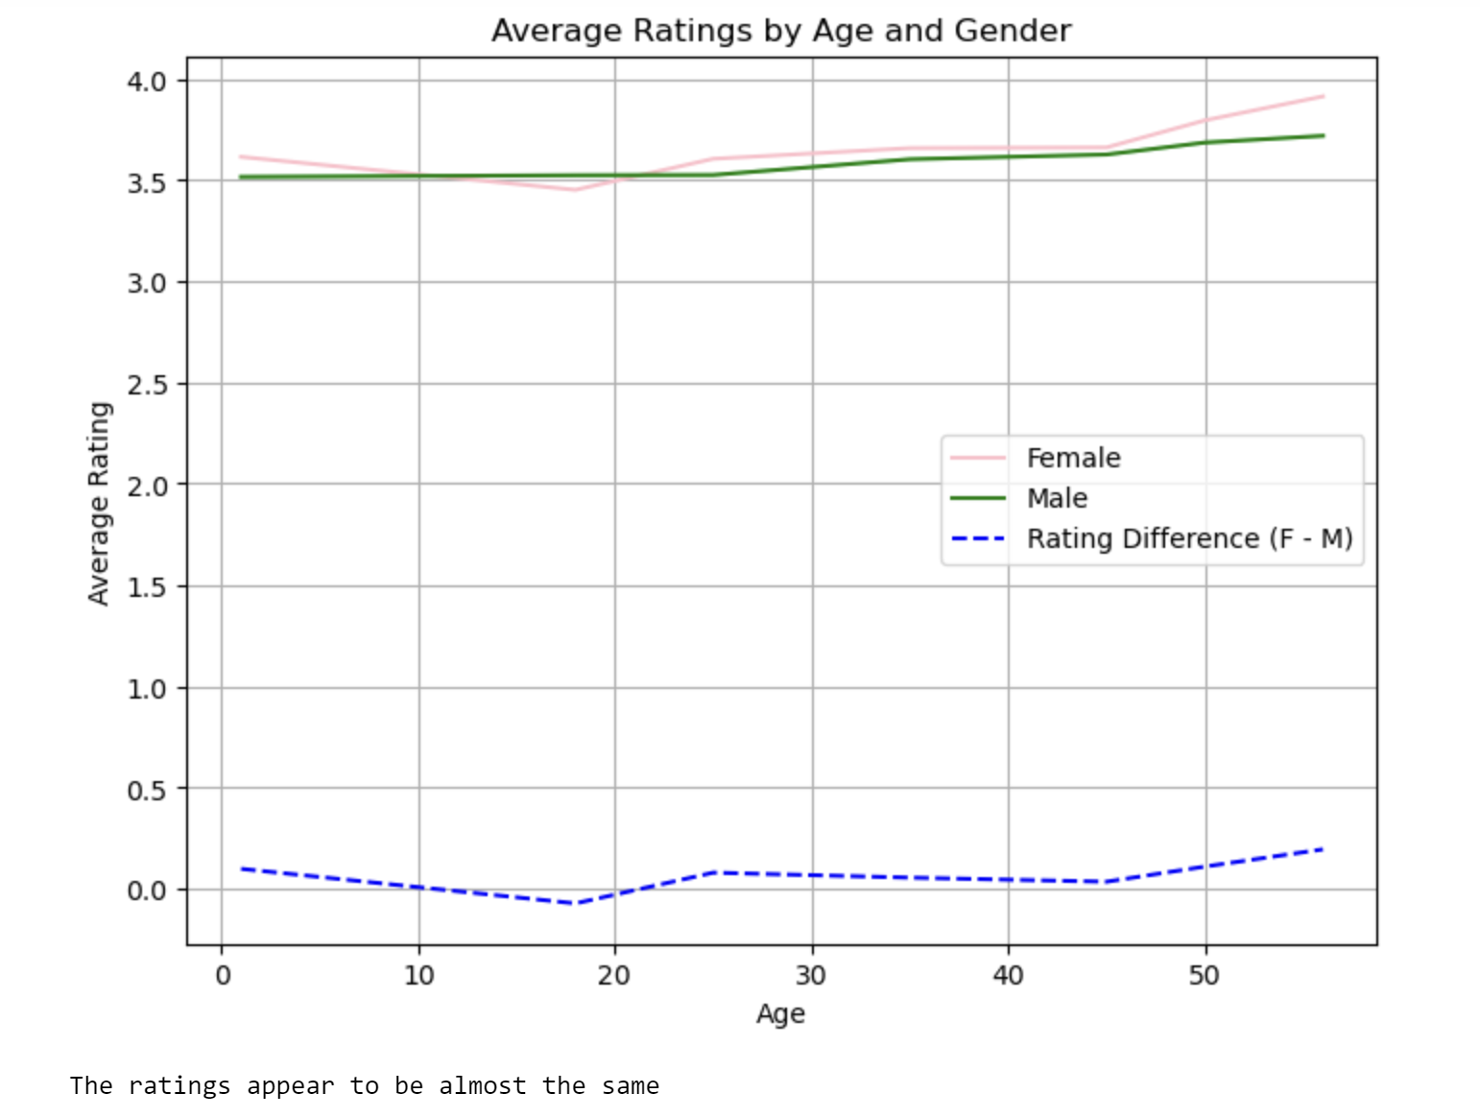

Conjecture 3a)

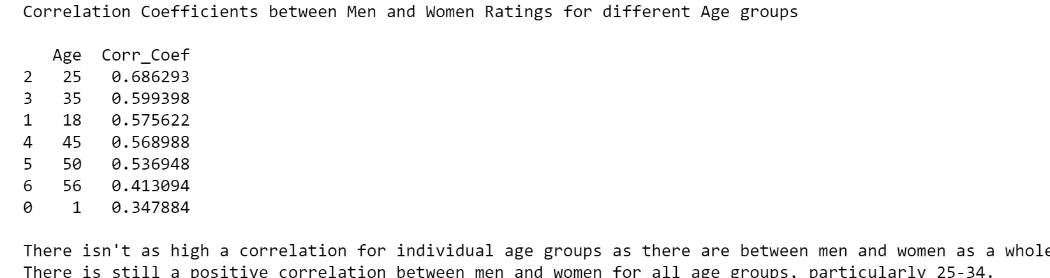

Conjecture 3b)

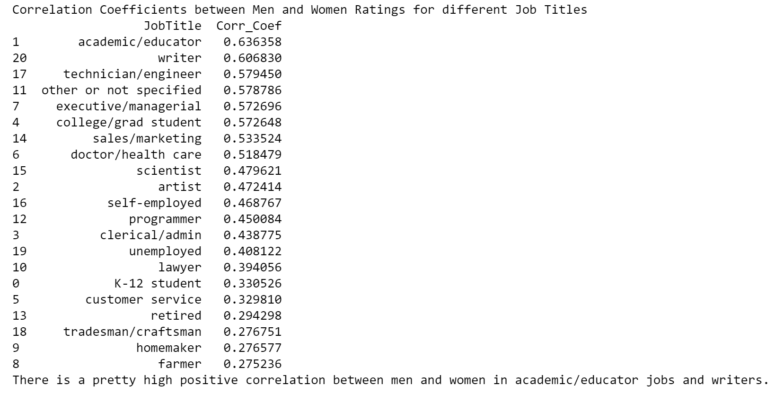

# **Business Intelligence**

We propose the question "What demographic and movie genres should we focus on to maximize the success of our upcoming movie releases?"

# **Conjecture 1:** Movies are popular the most among College and Graduate student

Amount of rating in different occupations

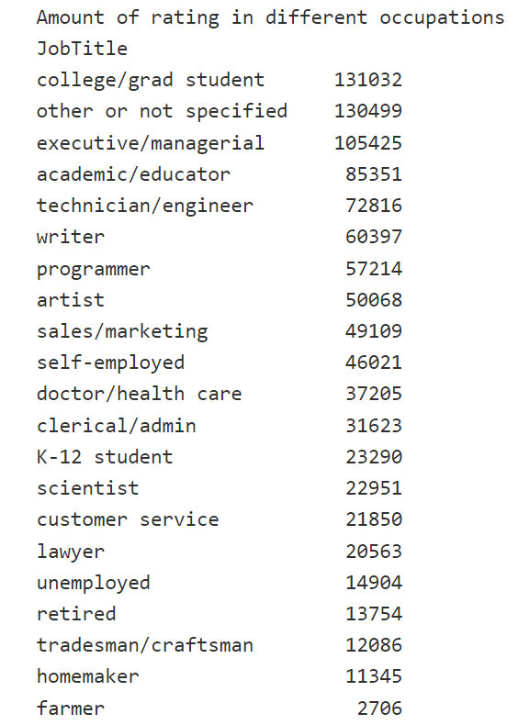

This data frame provides an overview of the amount of ratings across different occupation groups. From the data frame, we can easily recognize the trend of college or graduate students being the most movie enthusiasts. Leveraging this information for enhanced business intelligence, we can maximize our investing money, especially in marketing. This means we should spend more money or prioritize investing in advertising about movies at the university. From this idea, what we can get from this conjecture is we will partly know the priority and portion of the investment for each different occupation group. This will help maximize the business investment.

One surprising fact that we found in this data frame is that higher workload occupations tend to watch movies a lot more than other occupations such as retirement and unemployment. This may be explained by the busy occupations that prefer having fast and less time-consuming forms of entertainment such as watching movies. We can also use this fact in our business intelligence. In this case, we can conclude that we should invest money in the technical and brainwork industry to maximize our investment.

# **Conjecture 2**: Gender-Neutral Marketing is more effective for Certain Genres

## 

* Correlation coefficient between male and female genre preferences: 0.97

While the overall correlation between men’s and women’s ratings is quite high, how will this correlation translate to individual genres?

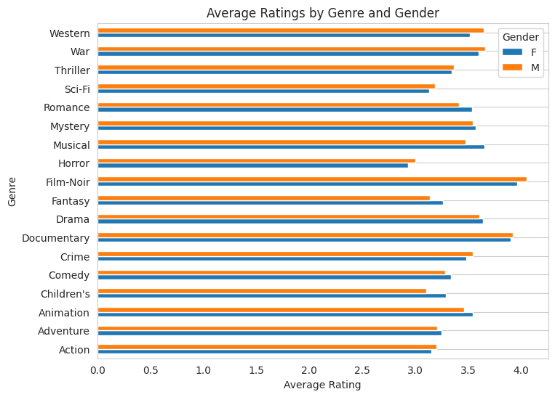

The first issue in investigating this problem is that Genres are concatenated into pipe-delimited strings, so it is difficult to compare movies that may share one, but not all, genres. In order to analyze ratings for individual genres, we can pivot and explode the values from the Genres column into a Genre column, with one row per movieID, userID, and Genre. This will have the effect of potentially duplicating movies in calculations that do not separate genre, but for this investigation it should provide useful information.

After doing so there appears to be a definite correlation between men and women, regardless of the genre, however some areas appear to have more of a correlation than others.

## 

By looking at a scatterplot of average rating by MovieID we can see the distribution of correlation between gender for individual genres, although this is easier to see if the genres can be separated. (see next page.

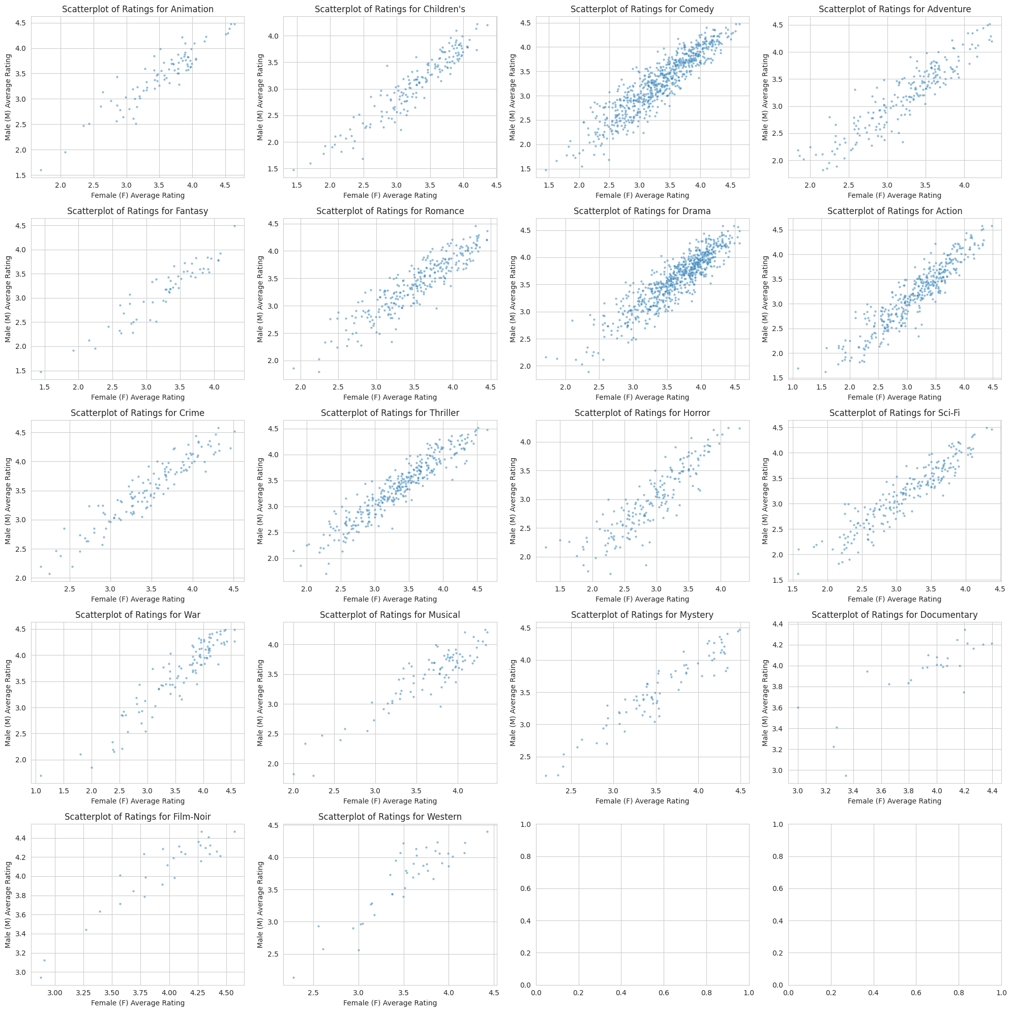

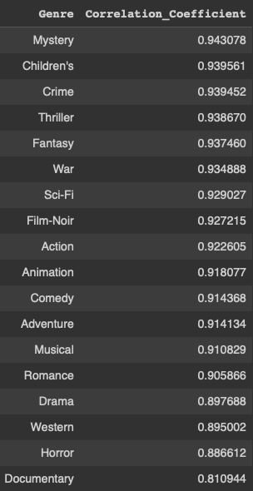

The Correlation Coefficients for each of the distinct genres is shown at right, indicating that some genres have a higher correlation, specifically Mystery, Children’s, Crime, Thriller, and Fantasy.

Other genres, such as Documentary, Horror or Westerns, have a lower correlation.

Business Decisions that this conjecture might help would be to use Genre as a tool to decide whether to market genres usually rated highly by one gender in areas typically associated with the other gender depending on which demographic has historically rated that genre higher. Gender does not seem to be a determining factor in whether users rate a movie highly in the Mystery, Children’s, Crime, or Thriller genres so you may want to market movies in these genres more than movies in the Documentary genre.

Additionally, you can create a correlation heatmap to determine what other genres you may want to suggest to users who have rated a certain genre highly, and filter the data to one gender or another when necessary.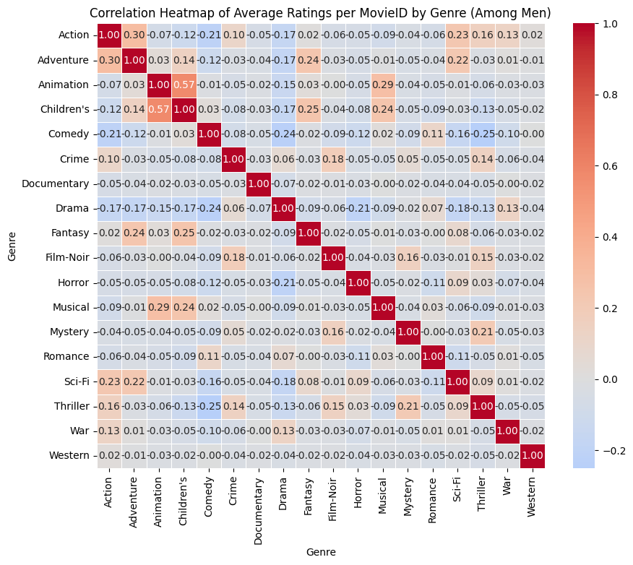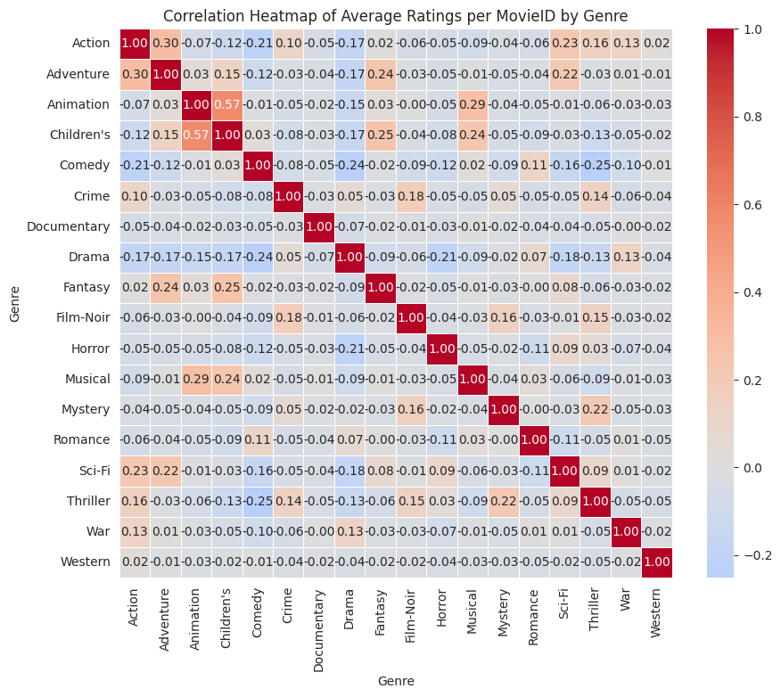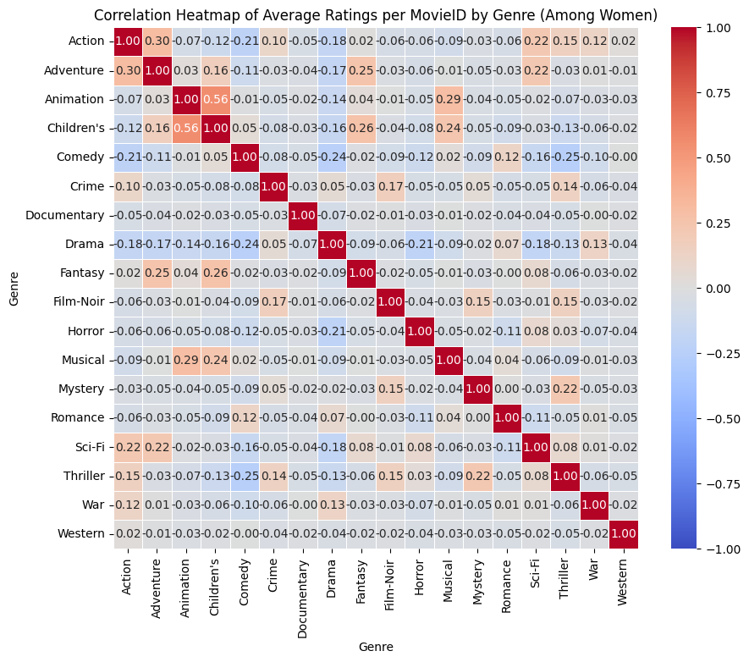

# **Conjecture 3**: Younger viewers, regardless of gender, tend to have similar ratings.

Without consideration of gender, the average rating across ages starts a little under the overall movie average rating of 3.62, which then dips at the 18-24 group, and then continues to rise.

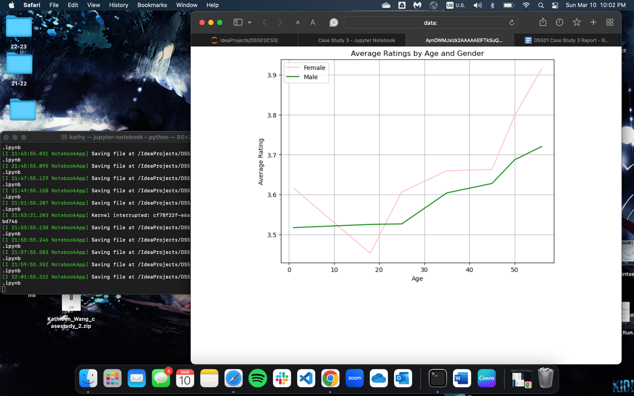

With consideration of gender, this trend is surprisingly only seen in female raters. Average ratings see a dip, and then increase to a plateau, and increase again. Male raters have a somewhat consistent increase in average ratings. Across all but one age, female raters on average tend to rate higher than male viewers. The average rating across gender is closest at the group 45-49, with 35-44 coming second. Interestingly enough, the largest rating difference across genders comes in the 56+ group. 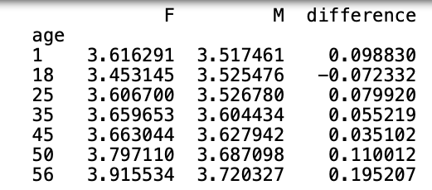

However, given our chosen popularity measure, we felt it was pertinent to also explore the number of users across the ages.

## 

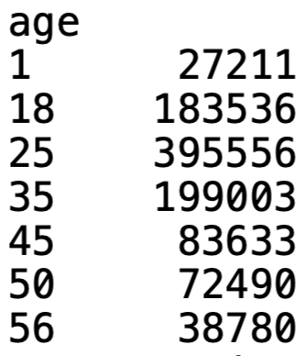

A large number of users fall within the 18-24, 25-34, 35-44 groups. We also see that this age group tends to have similar opinions on movies. To increase the user base of a streaming platform, we would recommend first focusing on this age range. Then, expand to the remaining age groups. However, it is also worth considering that it is likely that those under 18 do not feel inclined to rate movies, and may share accounts with parental users.

**Business Decision**

Based on Conjecture 1, we can conclude that watching movies are the most popular amongst College Student and Graduate Student, as well as Technical and Brainwork occupations. The fact that movies are popular amongst College Students is also supported in Conjecture 3, where the amount of reviews between 18-24 years old is the third largest amongst other age groups. Consequently, it can be inferred that targeting young adults in College and Graduate School will significantly boost the movie's popularity.

However, this age group is also the most critical reviewer, which potentially leads to a popular movie having a significant number of negative reviews. To address this, our strategy can pivot towards targeting age groups ranging from 25 to 44. This approach aligns with Conjecture 3, which highlights that the 25-34 and 35-44 age brackets contribute the highest number of reviews. On the contrary, individuals aged 45 and above, while generally more easily pleased, are less inclined towards movie consumption. Building upon the insights from Conjecture 1, it is essential to prioritize the adult audience, particularly those in technical careers, to maximize the movie's chances of attaining both popularity and positive ratings.

Another observation stemming from Conjecture 2 is that men tend to contribute more ratings compared to women. However, the correlation between movie ratings from men and women remains relatively high. Particularly in genres such as Mystery, Children’s, and Crime, where the disparity in audience preference between men and women can be minimized. This is evident as these three genres exhibit the highest correlation between male and female rating preferences.

In conclusion, we can pose a key business question: "What demographic and movie genres should we focus on to maximize the success of our upcoming movie releases?" Taking into account our dataset, we can determine that a Mystery, Children’s or Crime movie tailored to an adult audience in technical careers will have the highest probability of success, both in terms of popularity and favorable ratings.

**Story of the Group**

As a group, everyone worked on the coding aspect of the project. We had everyone attempt so we could be confident in our answers and have a variety of discoveries. Given that we had multiple different versions of answers, Phong took on the responsibility of combining the code for one submission. The group came together to brainstorm a business intelligence question, which we were able to finalize thanks to Nick’s suggestions. Kathleen, Phong, and Nick then worked on one conjecture each, creating their visualizations to be added to the report and presentation that Duyen created. Dan then took these conjectures and was able to expand upon how business intelligence questions could be answered.

The group worked individually, coming together to review and decide on various aspects to be included in the final deliverables. While we did have some scheduling conflicts, everyone was able to make the meetings thanks to Duyen, Phong, and Dan taking the initiative to schedule. Additionally, we did have one part of the exploration which we all had different answers. Kathleen gathered the process and the answers each person had and was able to identify a few issues that caused this difference in answers. She then suggested a method, and Dan was able to double-check and confirm her method.